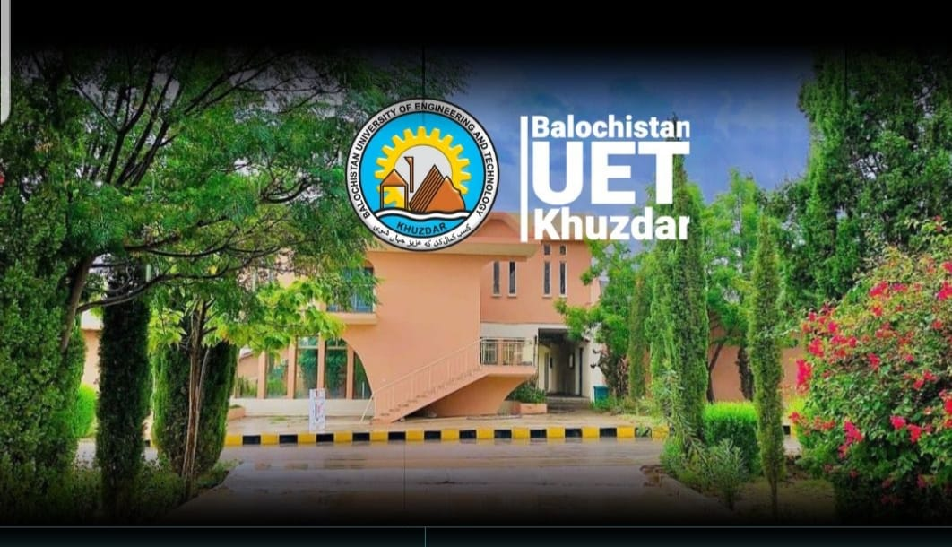  PROGRAMME  November 7, 2025 (Friday)  EVENT TIME  Registration 09:15 am – 09:30 am  Recitation from Holy Quran 09:30 am – 09:35 am  Opening Remarks & 09:35 am – 09:45 am  Introduction to CPD and PEC Bylaws  Reinforcement Learning Applications and Setup  Mr. Abdul Qadeer, Deputy Director (QEC), BUET, Khuzdar  Cell No. 0334-3422048, Tel: 0848-413049  Email: d.directorqec@buetk.edu.pk |   Pakistan Engineering Council  Short Courses Series  VENUE:  AUDITORIUM  BALOCHISTAN UNIVERSITY OF ENGINEERING AND TECHNOLOGY KHUZDAR   | RESOURCE PERSON  Dr. Khurshed Ali  He holds a doctorate in Electrical Engineering and Computer Science with specialization in Social Networks and Human-Centered Computing from the Academia Sinica and National Tsing Hua University, Taiwan, in 2021. His area of specializations is Reinforcement Learning, Social Networks Analysis, Machine Learning, and Human-Centered Computing. He has a Master’s degree in Software Engineering from Beijing University of Posts and Telecommunications, Karachi. He has more than 10 years of teaching experience. His research interests lie in Machine Learning, specifically in Reinforcement Learning in Social Networks Analysis and Cooling Optimization of Data Centers. He has more than fifteen publications in his credit, and he maintains an h-index of ten.
  Session-1 0945 - 1100
  Understanding the concept of Reinforcement Learning
  Tea Break 1100 - 1120
  Session-2 1120 - 1320
  Closing Remarks & Certificate 1320 - 1330
  Contact Person:
  Continuing Professional Development
  CPD
  Reinforcement Learning and Agentic AI
  On 7th November, 2025 (Friday)
 |  | A certificate of 1.0 CPD point will be awarded to the participants by PEC  - All Engineers registered with PEC  - Engineering Students  - Application from duly filled along with fee in the form of pay Order/Bank Draft in favor of Balochistan UET Khuzdar should reach on or the closing date on the following address:  (Office of the Director General QEC BUET, Khuzdar)  - Course fee: Rs. 500/- (For Engineers)  - Free for Students of BE Final Year of BUETK  Engr. Liaquat Ali Lehri  Director General QEC  Balochistan UET Khuzdar.  Office: 0848-413049  dgqec@buetk.edu.pk  www.buetk.edu.pk
  Module 1
  - Introduction to Reinforcement
  - Applications of Reinforcement Learning
  Purpose and Background
  - To Enlighten about the concepts, applications of Reinforcement Learning
  - To broaden the knowledge of Professional and registered engineers on various commands and techniques of Reinforcement learning
  Module 2
  - Reinforcement Learning in Social Networks
  - Reinforcement Learning Setups in multiple frameworks
  Purpose and Background
  - To Enlighten about the concepts, applications of Reinforcement Learning
  - To broaden the knowledge of Professional and registered engineers on various commands and techniques of Reinforcement learning
  Special Features of Workshop
  Who Should Attend?
  Registration Process
  Course Coordinator

